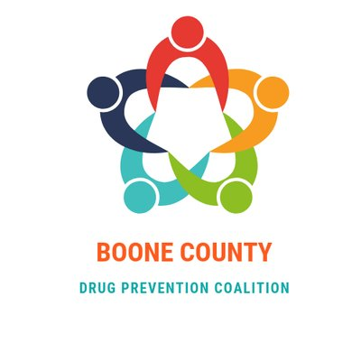
Video Contest Parent Permission Form
Participants under the age of 18 must submit a fully completed copy of this document in order for their video entry to be valid.

Participants Name:

School Name (optional): _________________________________________________________

Address: __________________________________ City: ____________________________

Email (non- school email): __________________________ Phone: ____________________

By signing this agreement, you affirm the following:

Participant:
I have read and understand the full official rules and guidelines and agree to abide by those rules.
I agree that it is okay to use the video if selected as a winner, to be posted on social media sites by the Boone County Drug Prevention Coalition.
I have full authority to enter this video into this contest and that the video is original and owned by me. If needed, I have obtained the necessary release and permissions to enter this contest.
I understand that in the event that my submission is selected as a winning entry, and the rights and/or originality of my entry cannot be verified to the satisfaction of the judges, an alternative winner may be selected in my place.

Participant’s Signature: ___________________________________________________
Date: _____________________________

Parent/Guardian:
I understand my child has submitted an original video to the Boone County Drug Prevention Coalition video contest for National Prevention Week. I grant full permission and authority to the Boone County Drug Prevention Coalition and anyone authorized by the coalition, to use, publish and display my child’s image and/or voice as it is contained in the video.

Parent/Guardian Name: _____________________________________________
Parent/Guardian Signature: ____________________________________________

Date: _________________________

Please complete this form and email the form submission to BCDPC@boonehealth.org or ABrouwer@boonehealth.org or come in and drop it off at 1204 Logan Ave Belvidere, IL 61008.

